# **2.- BUYER PERSONA**

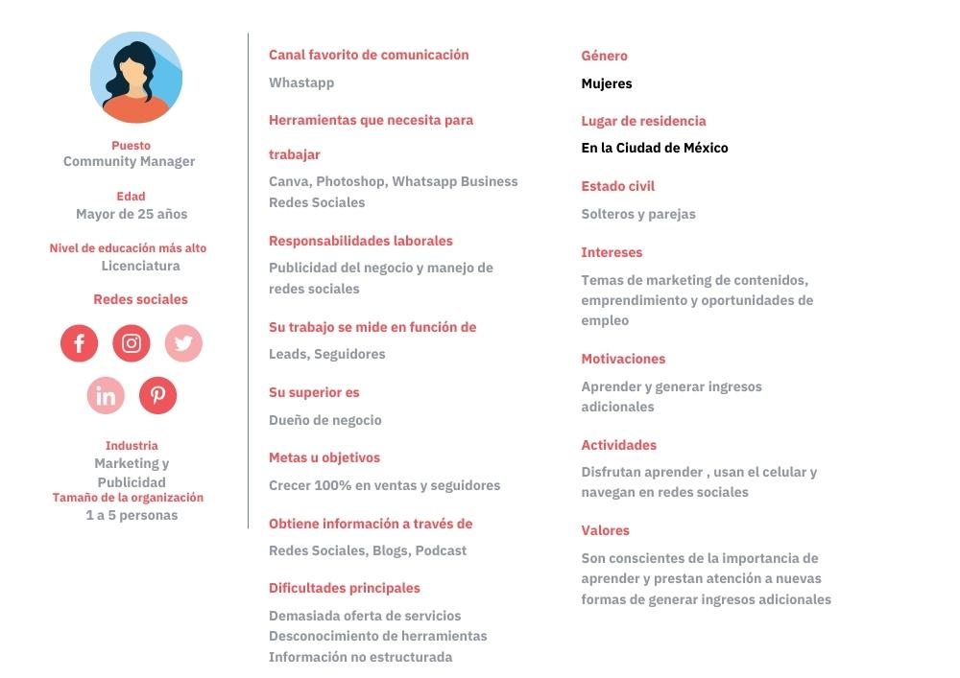

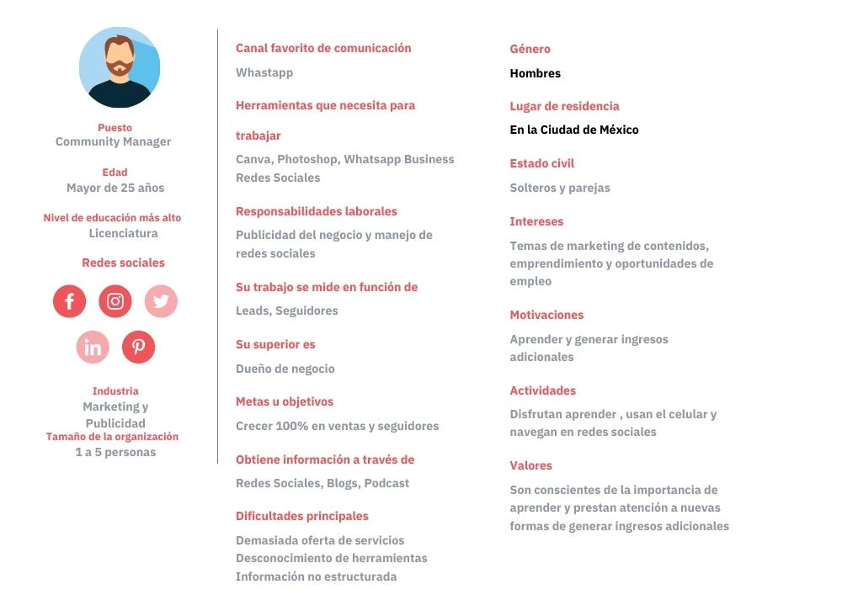

Realizado con herramienta canva:

<https://www.canva.com/design/DAE5aLH6bL4/lC5d-m2OrigZAVcsAYRw7g/view?utm_content=DAE5aLH6bL4&utm_campaign=designshare&utm_medium=link&utm_source=publishsharelink>